*I phone mobile*

I phone 14 pro max

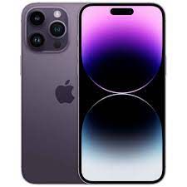

Apple **iPhone 14 Pro Max** · Released 2022, September 16 · 240g, 7.9mm thickness · iOS 16, up to iOS 17.3 · 128GB/256GB/1TB storage, no card slot

**PRICE /** 499,999 **PRK**